DENVER RTD EAGLE P3
COMMUNICATION SYSTEM

FIELD MODIFICATION INSTRUCTIONS
FMI #15: SOFTWARE UPDATE

CONTRACT NO. | P110701149
CDRL NO. | N/A
WIS DOC. NO. | 42A-2017-0053
REVISION: | 1.0
DESIGNED: | D. S. JANG
REVIEWED: | J. Y. LEE
APPROVED: | B. J. JONE
DATE: | 7/10/2017



Record of Revisions
Rev. | Date | Description | Entered By
1.0 | 7/10/2017 | Initial release | D. S. Jang

Table of Contents
1. Introduction 4
2. Summary 4
3. Instructions 4
3.1 Location of Equipment 4
3.2 Software Update DESCRIPTION 6
3.2.1 Updating CRA-LICL 6
3.3 TEST AND VERIFICATION. 6
3.4 VERSION ChECK 7
4. Tracking 7

Introduction
This FMI provides instructions to install the Communication System update to the vehicles.

Summary
This FMI applies to following software configuration item:
- CRA-LICL SW change.

Instructions

Location of Equipment
Following figures show the location of equipment to be updated.

Figure 1 –CRA- LIC Board Location

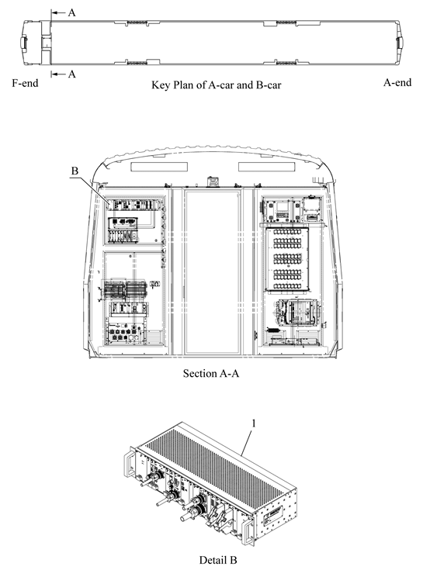
Figure 2 – CRA Location

Software Update DESCRIPTION

Updating CRA-LICL
1) Time Stamp address change according to MDS LonWorks MA/MB car communication interface change.
2) Update LonWorks SW(LICL) of CRA-LIC PCB.

3) Complete QT confirmation according to SW change.
- Check the updated SW by LonScanner file QT which was changed on March 2017.
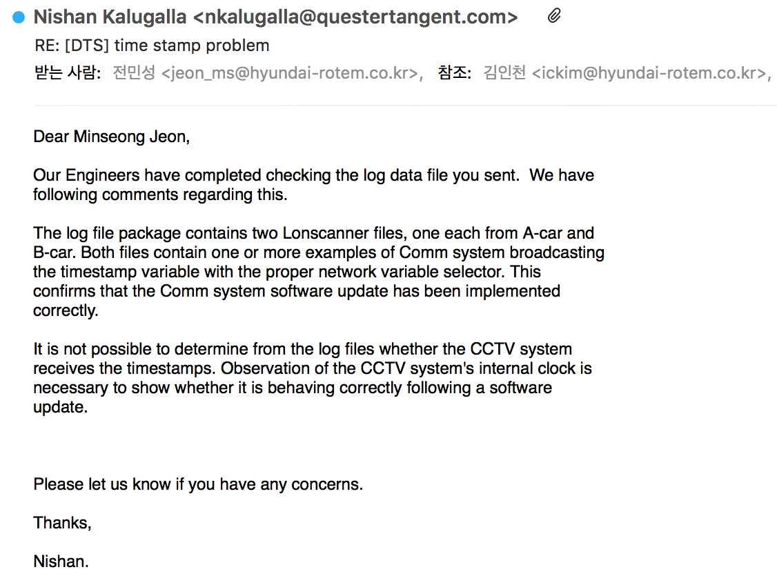

4) The logic of Time Stamp
CRA must provide the Time Stamp to MDS and must receive the request of sending for the Time Stamp from MDS.
The below block diagram is described for the Time Stamp. (Blue Line is indicated to the Ethernet Network, Red Line is indicated to the LonWorks.)
CRA must provide the Time Stamp to MDS and must receive the request of sending for the Time Stamp from MDS.
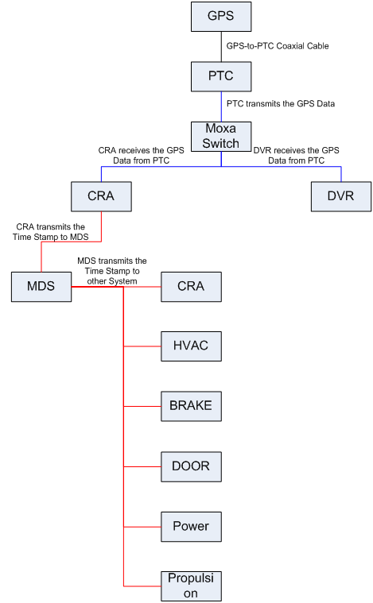

TEST AND VERIFICATION.
After updating the CRA-LICL software, follow the procedure below to verify the functionality:
1) MDS <-> CRA-LIC interface function check
- Information for Time, equipment status and version

VERSION ChECK
Use the MDS Software Version menu to verify the updated software versions.
- CRA-LICL : Version-1.1.03, Build Date – 2017-03-20.

Tracking
Status of the field modification activities will be tracked and managed for car number and items completed. The progress will be reported to DTP/H-Rotem in daily basis as the modification proceeds.

